Fauquier Community Action Committee
HEAD START

Annual Report 2017-2018

Mission Statement

The Mission of the F.C.A.C. Head Start Program is:

“To provide a quality and comprehensive
Head Start program for the
children and families that we serve.”

Incorporating other services directed toward promoting total family self-sufficiency, encouraging parents to take an active role in the education of their children and transitioning the children into the school system by mobilizing all available resources through community awareness, involvement, and support.

BOARD OF DIRECTORS AND POLICY COUNCIL

Board of Directors

Janice McNulty- President
John Harrison- Vice President
Catherine Boyce- Secretary,
ECH Education
Christy Minor- Treasurer, Fiscal
Ann Calloway- Lawyer
Roger Sites- Member
David Lee-Member
Steve Payne-Member

Policy Council Officers

Amanda Escamilla-President
Cheryl Walker-Vice President
Tacarra Crawford– Secretary
Ashley Jennings-Assistant Secretary
Tamara Brooks-Treasurer
Representative to the Board of Directors– Melise Garofalo

FCAC Head Start Demographics

Administrative Staff:
Head Start Executive Director-Patricia A. Washington
Program Assistant/Receptionist- Terry Collins
Fiscal Officer- Bethany Walton
Education Manager- Patricia Washington
Health Services Manager-Sherry Brodnax
Mental Health/Coaching & Mentoring Case Manager- Ryan Washington
FS Disability/Coaching/Mentoring Case Manager- Kailyn Logan
Parent/Family Engagement Supervisor-Mildred Washington
Family Service Workers- Victoria Arellano
Stephanie Miller
Yoseli Flores

Head Start Education/Transportation Staff:
Teachers: 8
Assistants: 8
Bus Drivers: 6
Bus Monitors: 6

Head Start Classrooms:
FCAC Head Start has 8 classrooms in 3 centers throughout Fauquier County

Head Start 2017-2018 Budget

 | Awarded | Budget | Actual
Personnel | $823,389 | $823,389 | $804,122
Fringe Benefits | $164,554 | $164,554 | $173,145
Travel | $2,039 | $500 | $322
Equipment | $7,000 | $7,000 | $7,000
Supplies (Office/Classroom) | $17,810 | $23,005 | $15,639
Contractual/Consultants | $59,300 | $66,282 | $55,784
Other | $67,759 | $57,121 | $85,839
Non-Federal Share | $288,154 | $288,154 | $288,154
T&TA (Training and Technical Assistance) | $17,766 | $17,766 | $17,766
TOTAL HEAD START APPROVED BUDGET | $1,159,617 | $1,159,617 | $1,159,617

Education

Achievements:

Child Development Associate Credential (CDA)

1 Teacher Assistant received her CDA
3 Teacher Assistants will receive her CDA in the Fall 2018
Associates Degree
1 Teacher will receive her Associates degree in Early Childhood Education Spring 2018

Head Start Reading Program
Every family was encouraged to read at least one book to their child every week of the month for the months of November, January, February, March and April.
The families read a total of 2,800 books since October 2017

Parent Activity Calendar

Parent Activity Calendars were sent home monthly to all the families. The activity calendar had a variety of activities for parents to complete with their child to promote school readiness in the home. Every month the calendar featured a different aspect of school readiness.
The families completed a total of 169 parent activity calendars

Teddy Bear/Transition Picnic
The Fauquier County Public Library provided the parents with information about the library, the activities that they offer, and provided the information to obtain a library card for themselves and or their children. Dominion Power dropped off backpacks and supplies to the children transition to kindergarten. Fauquier F.I.S.H. provided parents with information about obtaining backpacks and school supplies for those that need it.

School Readiness
School Readiness is a high priority for Head Start programs. Head Start’s approach to school readiness means that children are ready for school and families support their children’s learning. The Head Start program partners with parents in establishing kindergarten readiness goals that support children’s progress across five early childhood learning domains. These domains include (1) language & literacy (2) cognition, (3) approaches towards learning, (4) perceptual, motor, and physical development and (5) social and emotional development. These domains represent a critical area of learning and development for young children. All goals are aligned with the Head Start Framework, State Early Learning Standards, and Virginia Foundation Blocks for Early Learning. Parents are encouraged to be involved in their child’s school readiness whether through reading to their children, activities in the home, or attending parent center meetings/trainings with the focus on school readiness.

Summary
The overall scores for FCAC Head Start were great and had a steady growth throughout the year. In Fall/Winter/Spring of 2018 the four year old teachers should focus on Language and literacy domain. More specifically goal P LIT 6, writing with a purpose. Getting the children to understand the written word is spoken work and vice versa. Making the connection in books. For the three year olds the focus should be physical development, more specifically fine motor skills. This will insure children are able to do self-help skills such as: zipping coats and buttoning pants.

Table of Contents
- Four Year Old Overall Scores
- Three Year Old Overall Scores
- ESL Overall Scores
- Individual School Readiness Goals by Classroom
  - Approaches to Learning
  - Social and Emotional Development
  - Language and Literacy
  - Mathematics
  - Perceptual, Motor, and Physical Development

Four Year Old Overall Fall Scores
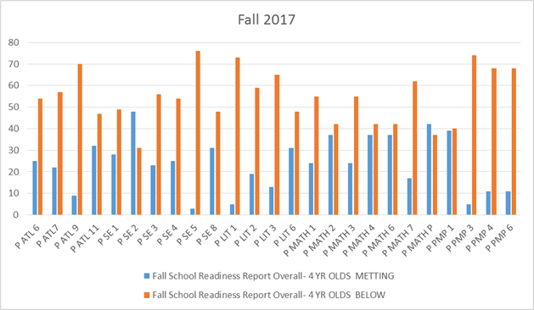

This graph shows the overall score for the four year olds in the fall of 2017. The blue indicates the children that are meeting the Goal. The orange shows the children that are not meeting the goal according to FCAC Head Starts goals for the program. Children that are in the orange are in the age appropriate range for children nation-wide through Teaching Strategies. In the Domain Approaches to Learning (P ATL 6, 7, 9, 11) there are children that have not met the goal but 48% are in the age appropriate color range. In the Domain Social and Emotional Development (P SE 1, 2, 3, 4, 5, 8) there are children that have not met the goal but 47% are in the age appropriate color range. In the Domain Language and Literacy (P LIT 1, 2, 3, 6) there are children that have not met the goal but 44% are in the age appropriate color range. . In the Domain Mathematics (P MATH 1, 2, 3, 4, 6, 7, P) there are children that have not met the goal but 38% are in the age appropriate color range. In the Domain Perceptual, Motor, and Physical Development (P PMP 1, 3, 4, 6) there are children that have not met the goal but 66% are in the age appropriate color range.

Four Year Old Overall Winter Scores

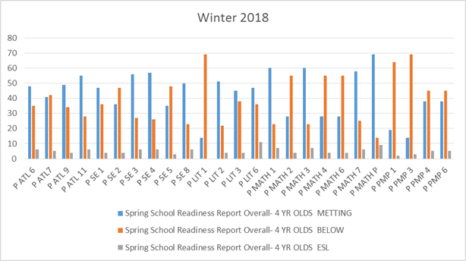

This graph shows the overall score for the four year olds in the winter of 2018. The blue indicates the children that are meeting the Goal. The orange shows the children that are not meeting the goal according to FCAC Head Starts goals for the program, and the grey indicates the number of ESL students meeting the goal. Children that are in the orange are in the age appropriate range for children nation-wide through Teaching Strategies. In the Domain Approaches to Learning (P ATL 6, 7, 9, 11) there are children that have not met the goal but 60% are in the age appropriate color range. In the Domain Social and Emotional Development (P SE 1, 2, 3, 4, 5, 8) there are children that have not met the goal but 65% are in the age appropriate color range. In the Domain Language and Literacy (P LIT 1, 2, 3, 6) there are children that have not met the goal but 56% are in the age appropriate color range. . In the Domain Mathematics (P MATH 1, 2, 3, 4, 6, 7, P) there are children that have not met the goal but 42% are in the age appropriate color range. In the Domain Perceptual, Motor, and Physical Development (P PMP 1, 3, 4, 6) there are children that have not met the goal but 72% are in the age appropriate color range.

Four Year Old Overall Spring Scores
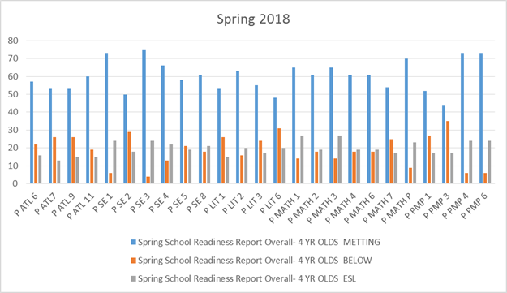
This graph shows the overall score for the four year olds in the spring of 2018. The blue indicates the children that are meeting the Goal. The orange shows the children that are not meeting the goal according to FCAC Head Starts goals for the program, and the grey indicates the number of ESL students meeting the goal. Children that are in the orange are in the age appropriate range for children nation-wide through Teaching Strategies. In the Domain Approaches to Learning (P ATL 6, 7, 9, 11) there are children that have not met the goal but 70% are in the age appropriate color range. In the Domain Social and Emotional Development (P SE 1, 2, 3, 4, 5, 8) there are children that have not met the goal but 80% are in the age appropriate color range. In the Domain Language and Literacy (P LIT 1, 2, 3, 6) there are children that have not met the goal but 78% are in the age appropriate color range. . In the Domain Mathematics (P MATH 1, 2, 3, 4, 6, 7, P) there are children that have not met the goal but 75% are in the age appropriate color range. In the Domain Perceptual, Motor, and Physical Development (P PMP 1, 3, 4, 6) there are children that have not met the goal but 80% are in the age appropriate color range.

Three Year Old Overall Fall Scores
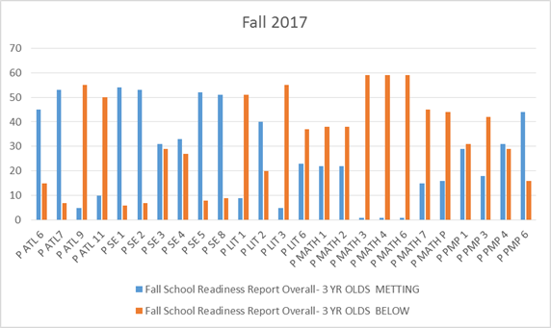

This graph shows the overall score for the three year olds in the fall of 2017. The blue indicates the children that are meeting the Goal. The orange shows the children that are not meeting the goal according to FCAC Head Starts goals for the program. Children that are in the orange are in the age appropriate range for children nation-wide through Teaching Strategies. In the Domain Approaches to Learning (P ATL 6, 7, 9, 11) there are children that have not met the goal but 73% are in the age appropriate color range. In the Domain Social and Emotional Development (P SE 1, 2, 3, 4, 5, 8) there are children that have not met the goal but 86% are in the age appropriate color range. In the Domain Language and Literacy (P LIT 1, 2, 3, 6) there are children that have not met the goal but 71% are in the age appropriate color range. In the Domain Mathematics (P MATH 1, 2, 3, 4, 6, 7, P) there are children that have not met the goal but 20% are in the age appropriate color range. In the Domain Perceptual, Motor, and Physical Development (P PMP 1, 3, 4, 6) there are children that have not met the goal but 27% are in the age appropriate color range.

Three Year Old Overall Winter Scores

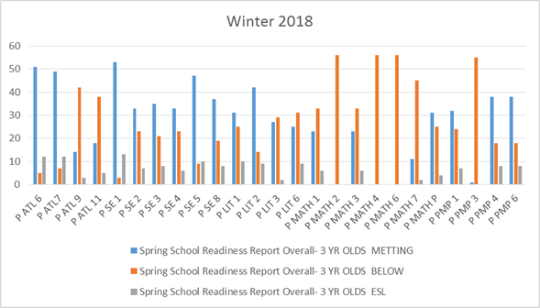

This graph shows the overall score for the three year olds in the winter of 2018. The blue indicates the children that are meeting the Goal. The orange shows the children that are not meeting the goal according to FCAC Head Starts goals for the program, and silver indicates ESL students that have met the goal. Children that are in the orange are in the age appropriate range for children nation-wide through Teaching Strategies. In the Domain Approaches to Learning (P ATL 6, 7, 9, 11) there are children that have not met the goal but 80% are in the age appropriate color range. In the Domain Social and Emotional Development (P SE 1, 2, 3, 4, 5, 8) there are children that have not met the goal but 92% are in the age appropriate color range. In the Domain Language and Literacy (P LIT 1, 2, 3, 6) there are children that have not met the goal but 85% are in the age appropriate color range. In the Domain Mathematics (P MATH 1, 2, 3, 4, 6, 7, P) there are children that have not met the goal but 35% are in the age appropriate color range. In the Domain Perceptual, Motor, and Physical Development (P PMP 1, 3, 4, 6) there are children that have not met the goal but 40% are in the age appropriate color range.

3 Year Old Overall Scores
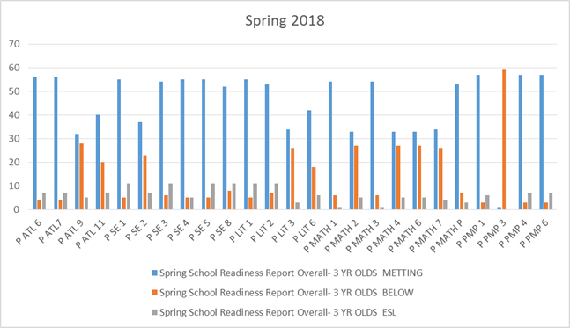
This graph shows the overall score for the three year olds in the spring of 2018. The blue indicates the children that are meeting the Goal. The orange shows the children that are not meeting the goal according to FCAC Head Starts goals for the program, and silver indicates ESL students that have met the goal. Children that are in the orange are in the age appropriate range for children nation-wide through Teaching Strategies. In the Domain Approaches to Learning (P ATL 6, 7, 9, 11) there are children that have not met the goal but 88% are in the age appropriate color range. In the Domain Social and Emotional Development (P SE 1, 2, 3, 4, 5, 8) there are children that have not met the goal but 95% are in the age appropriate color range. In the Domain Language and Literacy (P LIT 1, 2, 3, 6) there are children that have not met the goal but 94% are in the age appropriate color range. In the Domain Mathematics (P MATH 1, 2, 3, 4, 6, 7, P) there are children that have not met the goal but 65% are in the age appropriate color range. In the Domain Perceptual, Motor, and Physical Development (P PMP 1, 3, 4, 6) there are children that have not met the goal but 62% are in the age appropriate color range.

ESL overall Scores
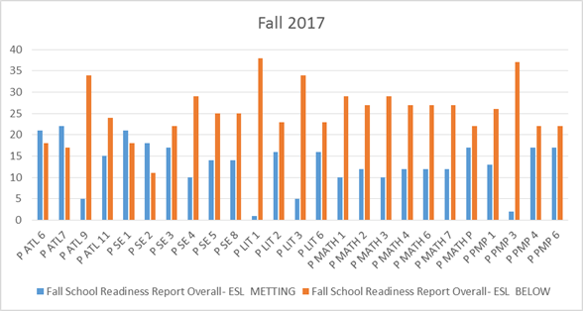

This graph shows the overall score for the ESL students in the fall. The blue indicates the children that are meeting the Goal. The orange shows the children that are not meeting the goal according to FCAC Head Starts goals for the program. Children that are in the orange are in the age appropriate range for children nation-wide through Teaching Strategies. In the Domain Approaches to Learning (P ATL 6, 7, 9, 11) there are children that have not met the goal but 72% are in the age appropriate color range. In the Domain Social and Emotional Development (P SE 1, 2, 3, 4, 5, 8) there are children that have not met the goal but 69% are in the age appropriate color range. In the Domain Language and Literacy (P LIT 1, 2, 3, 6) there are children that have not met the goal but 37% are in the age appropriate color range. In the Domain Mathematics (P MATH 1, 2, 3, 4, 6, 7, P) there are children that have not met the goal but 59% are in the age appropriate color range. In the Domain Perceptual, Motor, and Physical Development (P PMP 1, 3, 4, 6) there are children that have not met the goal but 72% are in the age appropriate color range.

ESL overall Scores
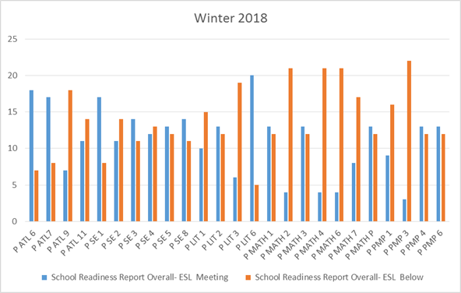

This graph shows the overall score for the ESL students in the winter. The blue indicates the children that are meeting the Goal. The orange shows the children that are not meeting the goal according to FCAC Head Starts goals for the program. Children that are in the orange are in the age appropriate range for children nation-wide through Teaching Strategies. In the Domain Approaches to Learning (P ATL 6, 7, 9, 11) there are children that have not met the goal but 85% are in the age appropriate color range. In the Domain Social and Emotional Development (P SE 1, 2, 3, 4, 5, 8) there are children that have not met the goal but 75% are in the age appropriate color range. In the Domain Language and Literacy (P LIT 1, 2, 3, 6) there are children that have not met the goal but 48% are in the age appropriate color range. In the Domain Mathematics (P MATH 1, 2, 3, 4, 6, 7, P) there are children that have not met the goal but 67% are in the age appropriate color range. In the Domain Perceptual, Motor, and Physical Development (P PMP 1, 3, 4, 6) there are children that have not met the goal but 81% are in the age appropriate color range.

ESL Overall Scores
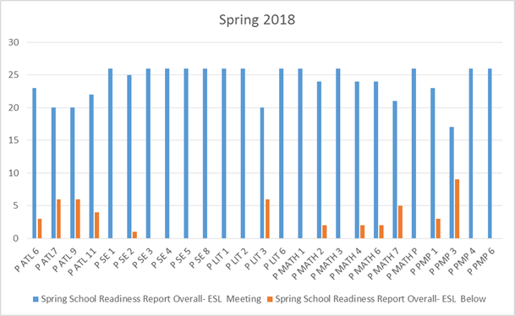
This graph shows the overall score for the ESL students in the spring. The blue indicates the children that are meeting the Goal. The orange shows the children that are not meeting the goal according to FCAC Head Starts goals for the program. Children that are in the orange are in the age appropriate range for children nation-wide through Teaching Strategies. In the Domain Approaches to Learning (P ATL 6, 7, 9, 11) there are children that have not met the goal but 92% are in the age appropriate color range. In the Domain Social and Emotional Development (P SE 1, 2, 3, 4, 5, 8) there are children that have not met the goal but 87% are in the age appropriate color range. In the Domain Language and Literacy (P LIT 1, 2, 3, 6) there are children that have not met the goal but 82% are in the age appropriate color range. In the Domain Mathematics (P MATH 1, 2, 3, 4, 6, 7, P) there are children that have not met the goal but 85% are in the age appropriate color range. In the Domain Perceptual, Motor, and Physical Development (P PMP 1, 3, 4, 6) there are children that have not met the goal but 89% are in the age appropriate color range.

Approaches to Learning by Classroom
Children engaged in learning, showing creativity in thinking, and curiosity in learning

- P ATL 6- Child maintains and sustains attention with minimal adult support
- P ATL 7- Child persist
- P ATL 9- Child demonstrates flexibility in thinking and behavior
- P ATL 11- Child shows interest in and curiosity about the world around them

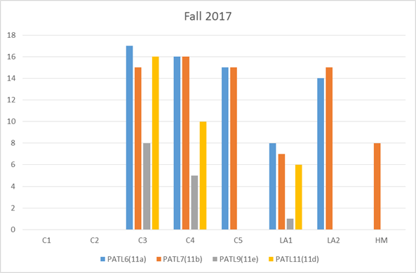

This chart shows the children that have reached the fall goal for approaches to learning. As mentioned about 48% of four year olds are in the age appropriate range and 73% of three year olds are in the age appropriate range.

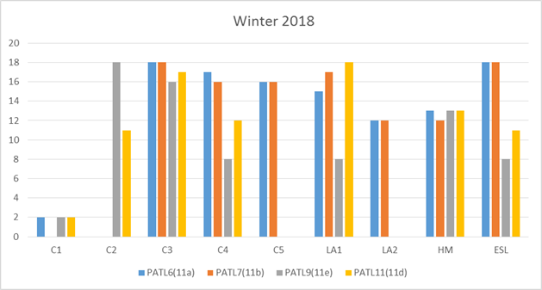

This chart shows the children that have reached the goal for the winter assessment in approaches to learning.
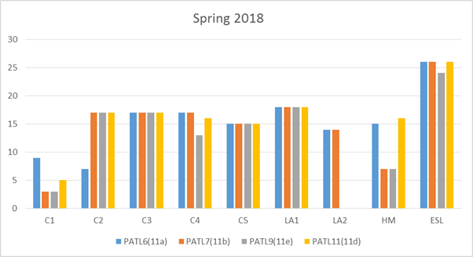
This chart shows the children that have reached the goal for the spring assessment in approaches to learning.
Social and Emotional Development
Children will engage in positive interactions with adults and peers

- P SE 1- Child engages in and maintains positive relationships and interactions with adults
- P SE 2- Child engages in prosocial and cooperative behavior with adults
- P SE 3- Child engages in and maintains positive interactions and relationships with other children
- P SE 4- Child engages in cooperative play with other children
- P SE 5- Child uses basic problem-solving skills to resolve conflicts with other children
- P SE 8- Child manages emotions with increasing independence

- 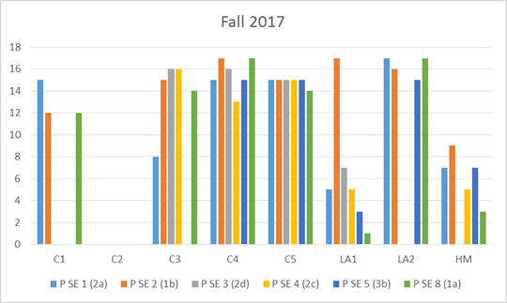

This chart shows the children that have reached the fall goal for social and emotional development. As mentioned about 43% of four year olds are in the age appropriate range and 86% of three year olds are in the age appropriate range

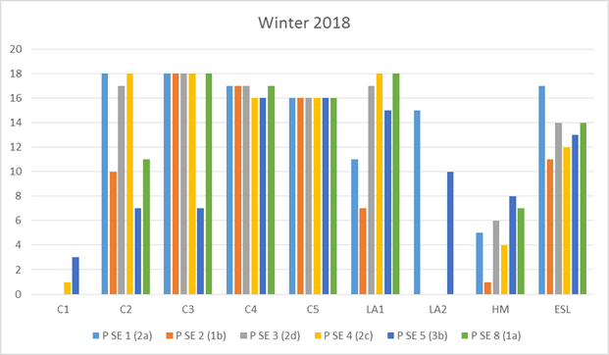

This chart shows the children that have reached the goal for the winter assessment in social and emotional development.

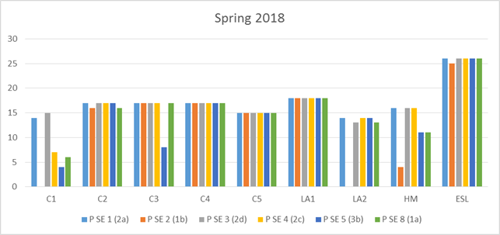
This chart shows the children that have reached the goal for the spring assessment in social and emotional development.
Language and Literacy
Children will understand and use print as a meaningful and organized system of communication

- P LIT 1 – Child demonstrates awareness that spoken language is composed of smaller segments of sound
- P LIT 2 – Child demonstrates how print is used and the rules that govern how print works
- P LIT 3 – Child identifies letters in alphabet
- P LIT 6 – Child writes for a variety of purposes using increasingly sophisticated marks

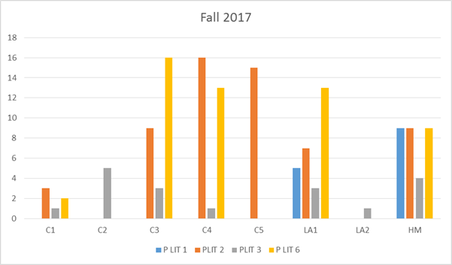

This chart shows the children that have reached the fall goal for language and literacy. As mentioned about 44% of four year olds are in the age appropriate range and 71% of three year olds are in the age appropriate range

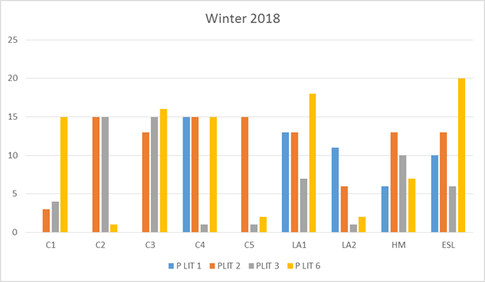

This chart shows the children that have reached the goal for the winter assessment in language and literacy.
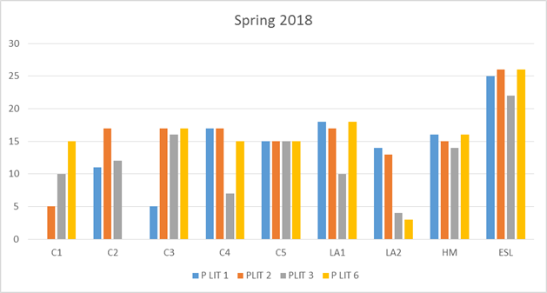This chart shows the children that have reached the goal for the spring assessment in language and literacy.
Mathematics
Children will develop the increasing ability to count, quantify, and identify patterns and shapes

- P MATH 1 – Children knows number names and count sequences
- P MATH 2 – Child recognizes the number of objects in a small set
- P MATH 3 – Child understands the relationships between numbers and quantities
- P MATH 4 – Child compares numbers
- P MATH 6 – Child understands addition as adding to and understands subtraction as taking away
- P MATH 7 – Child understands simple patterns
- P MATH P – Child understands shapes

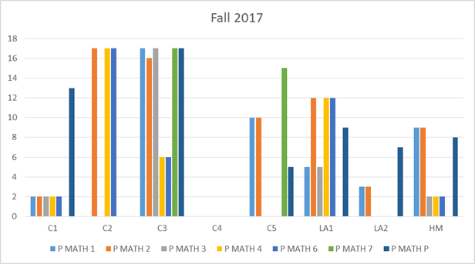

This chart shows the children that have reached the fall goal for mathematics. As mentioned about 38% of four year olds are in the age appropriate range and 20% of three year olds are in the age appropriate range

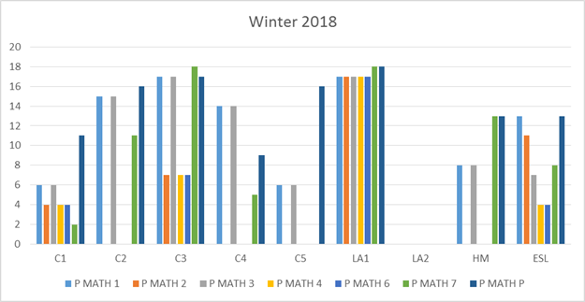
This chart shows the children that have reached the goal for the winter assessment in Mathematics.
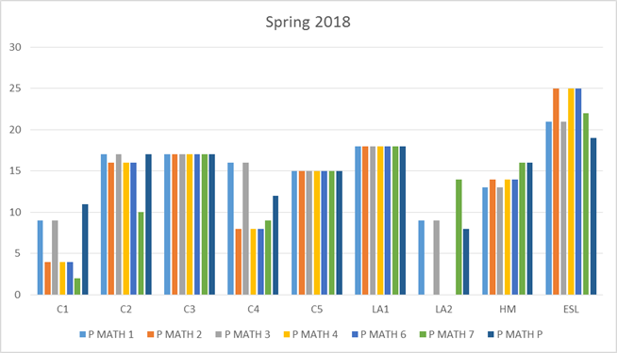
This chart shows the children that have reached the goal for the spring assessment in Mathematics.

Perceptual, Motor, and Physical Development
Children will develop fine and large muscle control and safe and healthy habits

- P PMP 1 – Child demonstrates control strength , and coordination in large muscles
- P PMP 3 – Child demonstrates increasing control, strength, and coordination of small muscles
- P PMP 4 – Child demonstrates person hygiene and self-care skills
- P PMP 6 – Child demonstrates knowledge of personal safety practices and routines

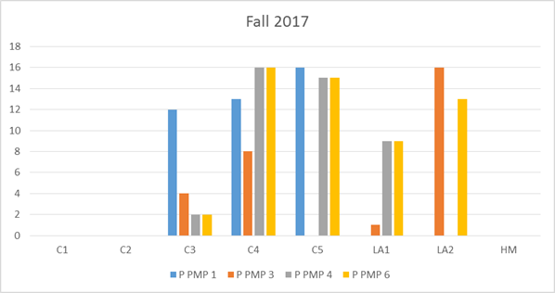

This chart shows the children that have reached the fall goal for perceptual, motor, physical development. As mentioned about 66% of four year olds are in the age appropriate range and 27% of three year olds are in the age appropriate range

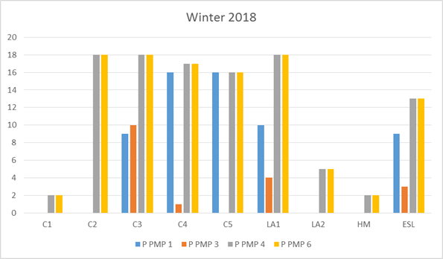
This chart shows the children that have reached the goal for the winter assessment in perceptual, motor, and physical development.
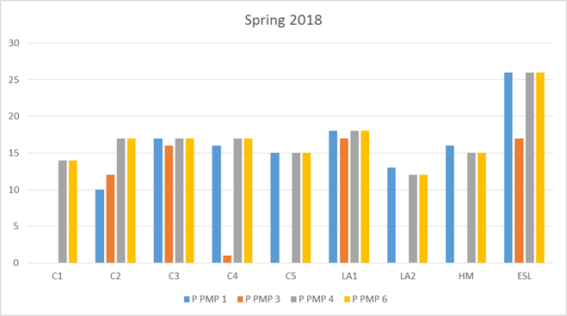
This chart shows the children that have reached the goal for the spring assessment in perceptual, motor, and physical development.
Curriculum and Screening Tools

FCAC Head Start uses the Creative Curriculum. The Creative Curriculum is a research-based curriculum that uses exploration and discovery as a way of learning, The Creative Curriculum enables children to develop confidence, creativity, and lifelong critical thinking skills. It is based on 38 objectives for development and learning, which are fully aligned with the Head Start Child Development and Early Learning Framework and the Virginia Foundation Blocks of Early Learning (Virginia State Standard).
Developmental and Social Emotional Screenings:

Brigance Screening Tool – Developmental screening administered in the fall and spring to all 3 and 4 year old children. The Brigance examines the following: color recognition, picture vocabulary, number recognition, body part recognition, visual discrimination, fine motor skills and gross motor skills. The Brigance helps to identify strengths and weaknesses and helps the teacher to individualize the activities for each child.

Devereux Early Childhood Assessment for Preschoolers Second Edition (DECA-P2)- Tool completed by the teacher in the fall and spring that looks at Initiative, Self- Regulation, Attachment/Relationships, and Behavioral Concerns

Pre K Pals
Children transitioning into Kindergarten are administered the Pre K PALS in the fall and spring. Pre K PALS is a scientifically-based phonological awareness and literacy screening that measures preschoolers’ developing knowledge of important literacy fundamentals and offers guidance to teachers for tailoring instruction to children’s specific needs. The assessment reflects skills that are predictive of future reading success and measures name writing ability, uppercase and lowercase alphabet recognition, letter sound and beginning sound production, print and word awareness, rhyme awareness and nursery rhyme awareness. The assessment scores indicate children’s strengths and those areas that may require more direct attention.

Parent, Family and Community Engagement

Achievements:

Family Service Worker Family Development Associate Credential
The goal of the Family Service Worker Training and Credentialing is a two year program designed to improve the effectiveness, quality and outcomes of the Family Service Workers. Family Service Workers play a critical role in developing and supporting the implementation of Head Start family partnership process. Currently 2 Family Service Workers and their Supervisor have already obtained their Family Development Associate Credential.

1 Family Service worker is taking classes toward the Family Development Associate (FDA) Credential

Community Partnerships- FCAC Head Start currently has partnerships with many community agencies to support the needs and goals of Head Start families and children. (For complete list please see pages 28-31.)

Follow Up
- Goal Follow-up: Family Service Workers followed up with each family on a monthly basis after the family goal had been set.

- Health Follow up: Family Service workers followed up on the children’s health needs including children needing Pediatric dental care, physical requirements, low hemoglobin, failed vision screens, etc.

- Classroom Concerns/Bus Concerns: Family Service workers work closely with each teacher and bus driver. When there was a concern the family service worker worked with the teacher and/or bus driver to help overcome any concern. These concerns included, consistently being late for the bus or not returning home activities. The family service workers followed up with the family, teacher and/or bus driver.

- Attendance: Family Service workers follow-up on children who have been absent 3 consecutive days.

Parent and Family Engagement Outcomes

Goal Setting- Each family is asked to set a goal during their first home visit with their family service worker, either for their family, themselves, or for their child. The family service worker works with each family throughout the year to give them the resources and information needed to complete their goal. The following chart shows goal progress from winter to spring. The numbers do not include children who dropped or children who came in late to the program.
By the End of November only 2 parents had completed their goal compared to 66 parents who completed their goal by the Spring. Goal progress is broken down into four steps, #1- No Progress, #2-Minimal Progress, #3- Some Progress, #4 Goal Accomplished. The following chart shows the number of families at each level in Winter and Spring. The numbers do not include children who dropped or children who came in late to the program.

Program Wide Family Partnership Goal Progress

Goal Progress | Winter | Spring
#1-No progress | 39 28% | 2 1%
#2- Minimal progress | 75 54% | 7 5%
#3- Some progress | 19 14% | 37 27%
#4- Goal accomplished | 6 4% | 93 67%
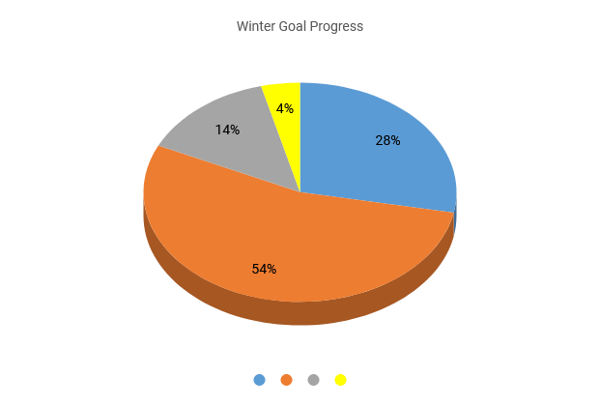

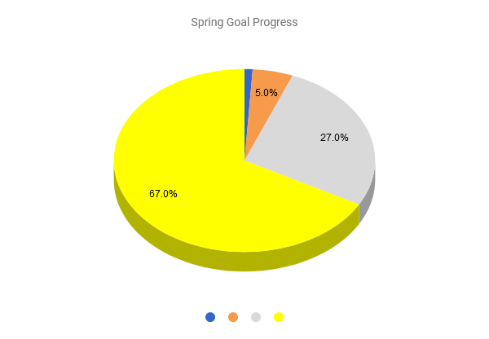

Scaled Family Assessment for Parent, Family and Community Engagement Outcomes

The Family Engagement component created the Scaled Family Assessment for Parent, Family and Community Engagement Outcomes to assess each family in the seven Family Engagement Outcomes. This outcomes instrument shows each family’s strengths and needs and shows how each family has progressed throughout the year. The Family Engagement component began using this instrument during the 2015-2016 school year. The instrument uses a scoring system with numbers 1-5, 1 being the lowest score (greatest need), and 5 being the highest (self-sufficient). Data was recorded at the end of December 2015 (Winter) and the end of May 2016 (Spring). While many families improved in one or more areas some families went down due to family situations such as losing a job or health problems. Each family service worker works closely with each of their families to ensure the family’s greatest needs are met.

As of 5/18 | 137 Spring Assessments Completed
139 children | 2 new children (Late Entry into the program)
1. Family Well Being | Score | # Children Winter | # Children Spring
I. Health: Medical, Dental, Vision
All family members have insurance and medical home | 5 | 51 | 58
Child has health insurance, family uses medical resources | 4 | 52 | 65
Child has health insurance, adult has no health insurance or resources | 3 | 29 | 13
No one has health insurance but has medical resources (medical home) | 2 | 2 | 3
No one has health insurance | 1 | 5 | 0
II Housing
Family has adequate, permanent housing | 5 | 72 | 79
Housing is somewhat adequate | 4 | 25 | 41
Family is renting/leasing but is not adequate | 3 | 31 | 17
Family has temporary housing but looking for permanent housing | 2 | 10 | 0
Family is homeless | 1 | 1 | 2 | 1 family moved out of the county with relatives and 1 family remained homeless
III Transportation |  | Winter | Spring
Has a vehicle, driver's license, and able to maintain vehicle | 5 | 78 | 84
Has vehicle and driver's license | 4 | 24 | 38
Has access to transportation | 3 | 29 | 16
Transportation problems, no driver's license | 2 | 8 | 1 | no driver’s license, no vehicle
No access to transportation | 1 | 0 | 0
IV Finances
Saving regularly and building assets, has savings | 5 | 2 | 10
Income meets basic needs, some savings | 4 | 34 | 73
Somewhat adequate income, no savings | 3 | 80 | 53
Poor credit, debt, relies on financial assistance | 2 | 22 | 3
No money, cannot meet basic needs | 1 | 1 | 0
V Employment
Stable employment with benefits, steady income | 5 | 22 | 36
Income meets needs, job advancement, benefits | 4 | 60 | 70
Adequate income, looking for better employment | 3 | 35 | 23
Unemployed but looking for employment | 2 | 20 | 8
Unemployed and not interested in employment | 1 | 2 | 2 | 1 parent is receiving disability benefits and the other is a foster parent
VI Childcare
Childcare is not needed/Regular quality childcare is used | 5 | 129 | 125
Childcare is used and is somewhat adequate | 4 | 9 | 14
Inconsistent childcare or multiple caregivers | 3 | 0 | 0
Problems with caregiver or limited back up | 2 | 1 | 0
Inappropriate child care or need childcare | 1 | 0 | 0
2. Positive Parent Child Relationships | score | Winter | Spring
Positive parenting practices, confident with parenting, consistent routines | 5 | 40 | 47
Effective discipline, routines are somewhat consistent | 4 | 43 | 72
Inconsistent or ineffective discipline, some routines | 3 | 46 | 20
Inappropriate discipline, minimal routines | 2 | 9 | 0
Little or no discipline, No routines | 1 | 1 | 0
3. Families as Lifelong Educators
Partners with teachers to set goals, met all goals for school readiness | 5 | 14 | 28
Actively participates in goal setting, met most goals for school readiness | 4 | 23 | 76
Participates in goal setting, met few parent goals for school readiness | 3 | 82 | 35
Limited ability or interest in child's education/goals for school readiness | 2 | 13 | 0
No participation in child's educational development | 1 | 0 | 0
4. Families as Learners
Has or is pursing a degree/certification | 5 | 29 | 24
High School graduate/GED, has goals for lifelong learning | 4 | 66 | 90
No diploma but seeking GED, willing to set goals for learning | 3 | 38 | 23
No diploma, limited ability to set educational goals | 2 | 6 | 2 | Parents was offered GED courses, but were not interested
Limited to no formal education, no interest in setting educational goals | 1 | 0 | 0
5. Family Engagement in Transition
Attends transition activities/conferences and is knowledgeable of the transition process | 5 | 18 | 30
Attends some transition activities and is knowledgeable | 4 | 33 | 76
Beginning to acquire knowledge of the transition process | 3 | 79 | 33
Inconsistent involvement in transition process | 2 | 8 | 0
No involvement in transition activities/conferences | 1 | 1 | 0
6. Family Connection to Peers and Community |  | Winter | Spring
Actively Participates in community activities, strong peer support | 5 | 10 | 12
Participates in some community activities, has peer support | 4 | 46 | 92
Attends some community activities, has limited support | 3 | 67 | 34
Limited participation in community activities, little support | 2 | 16 | 1 | Late Entry
Little or no community participation, no support | 1 | 0 | 0
7. Families as Advocates and Leaders
Actively engaged in leadership opportunities, advocates | 5 | 5 | 16
Participates in some leadership activities, advocates | 4 | 22 | 54
Limited participation in leadership activities, advocates some | 3 | 81 | 61
Limited ability to participate, advocates little to none | 2 | 29 | 6
No interest in leadership or advocacy opportunities | 1 | 2 | 2

Enrollment Statistics

The family service staff records all enrollment/attendance information on all children and families.

Total number of children served (includes dropped children)- 159

Eligibility by Primary Type of Eligibility

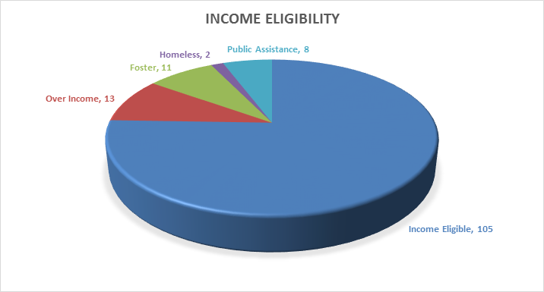ERSEA-Charts
Out of the 2 homeless families:
o 1 family moved out of county with relatives
o 1 family still remained homeless

Average Monthly Attendance for Program Year 2017-2018
It is required for all Head Start programs to have at a minimum 85% attendance each month.

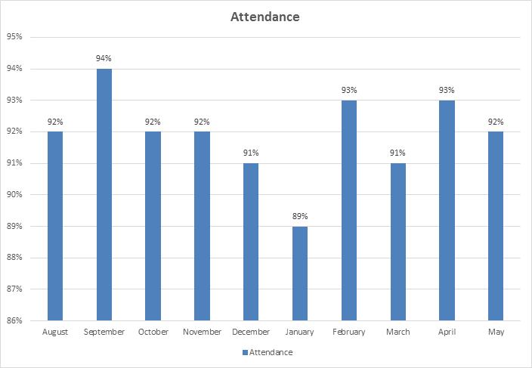

Year End Average Attendance for 2016-2017: 90%
Year End Average Attendance for 2017-2018: 92%

PARENT AND COMMUNITY ENGAGEMENT
Parent Involvement

Total Volunteer Hours- 1630.45

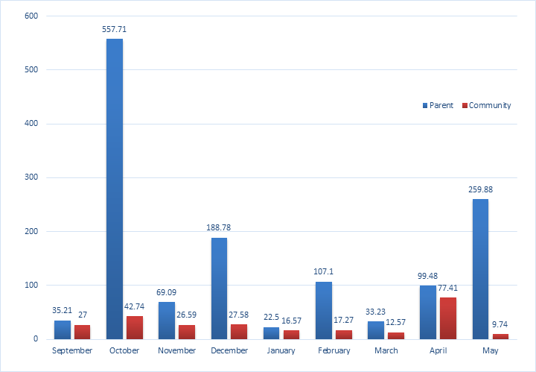

2016-2017: 1418.87
2017-2018: 1630.45
(increase of 211.58 hours)

Parent Involvement
FCAC Head Start offers many opportunities throughout the year for families to participate. All parents are invited to participate in all activities including…

- Parent Center Meetings: Once a Month
- Policy Council
- Volunteering in the classroom: (Helping teaching staff, eating lunch, special occasions etc.)
- Trainings/workshops: (Behavior, Literacy, Nutrition, Fatherhood etc.)
- Field Trips
  - Cox Farm- Pumpkin Patch in October
  - Library- Monthly
  - Highland School- watch school play and book drive for children
  - Individual Classroom field trips- Children’s museum, park, Carousel Frozen Treats, Brumfield Elementary etc.
- Health/Education/Family Engagement Advisory Board
  - Meeting with community organizations to discuss the Health/Education/Family needs of Head Start families and children.

Health Services

The focus of Head Start health services is to prevent health problems whenever possible by carefully addressing the needs of enrolled children. Successful partnerships are the key to the success of this approach. When conditions or illnesses are found, they are addressed quickly with the help of competent health care partners in an effort to improve the health of the child and to prevent future problems.

FCAC, Inc. Head Start Health Services provides:

- Health Screenings to all enrolled children including: Hearing, Vision, Speech and Language
- Assisting families in finding a medical home/dental home
- Tracking health services
- Offering trainings/information to families about: Nutrition, Family Wellness, Dental Awareness, Communicable diseases, child health and safety etc.

Health Services | At the End of the Program Year
Children with Health Insurance | 95.5%
Children with No Health Insurance | 4.4%
Children with a Medical Home | 100%
Children with Up to Date Immunizations | 100%
Children who received preventative dental care | 100%
*Children who required Dental Treatment | 18
*Completed Dental Treatment. | 14
*Currently In Dental Treatment | 0
*Children that dropped prior to receiving care | 5
*Refused Dental Treatment | 0
Children that received Speech and Language Screening | 99%
Children that received Hearing and Vision Screening | 99%
*Children referred to Pediatric Ophthalmologist | 22
*Children referred to Pediatric Ophthalmologist who received glasses | 19

Health Tracking

Health tracking is crucial to ensuring that children receive services in a timely manner. The Health Services Manager works with the community physicians to ensure that children are current on their physical exams and up to date with their immunizations according to the ESPDT guidelines. Children who need medical follow-up are reminded to take their children for rechecks and other necessary follow-up. The Health Services Manager works with the physicians to see if parents have followed-up with the concern conditions. The Health Services Manager and Family Service Workers work with the families in regards to chronic medical conditions and the physician’s office to acquire information in regarding the child status.
The Health Services Manager works closely with the Fauquier Free Dental Clinic to ensure that children receive and initial dental exam. Children who need further dental care are referred to a pediatric dentist within the county or surrounding areas.
The speech and language screening are done by a private speech pathologist. Referrals from these screenings are shared with the parents and with their permission follow-up is done with a community partner to ensure that the child receives the required services.
Hearing and Vision Screenings are done by the Fauquier Host Lions Club using the Spot Vision machine to do vision screens.

Chronic Medical Conditions
During Program year 2017-2018 there were 29 children being followed up by the health manager for chronic health conditions. The Health Services manager worked closely with each family to ensure their needs were being met. Children with Asthma are receiving medical care. Children who were anemic are no longer anemic. No children were diagnosed with obesity concerns. Child with chronic medical condition is being take care of by her physician.

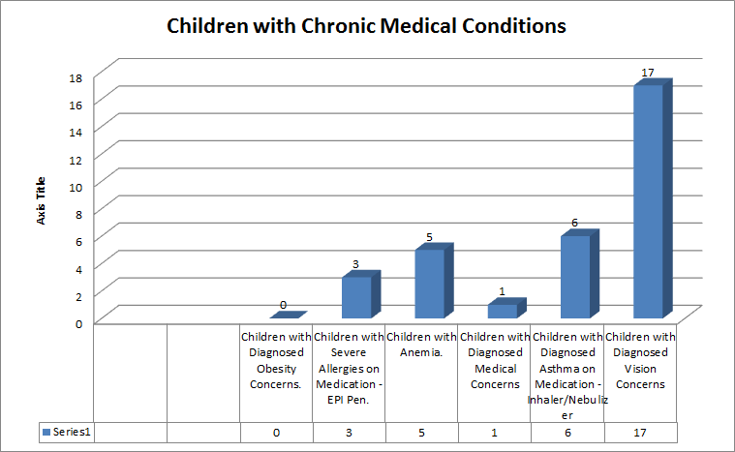
Disabilities
The Family Services/Disabilities Case Manager, teachers, and parents work closely together throughout the school year to ensure that every student maximizes his or her ability to learn. Each year our students are screened within 45 days of entering the classroom for speech and language, vision, and hearing. The teachers and assistants also administer developmental and literacy evaluations at the beginning and end of the school year to assess each child’s abilities, and we continue to monitor each child’s progress throughout the year. Our Head Start program works closely with Fauquier County Public Schools Special Education Department to help meet the educational needs of our students.

Disability Services
- Children that had an IEP and were determined to be eligible for services prior to enrollment year- 11
- Children that obtained an IEP and became eligible to receive services during enrollment year- 11
- Children referred for evaluations to receive services- 18
Of these:
  - Children who went to Child Study meeting- 18
  - Children who went to Eligibility meeting- 11
  - Children who went to IEP meeting- 11
- Children diagnosed with Developmental Delays- 1
- Children diagnosed with Speech/Language Impairment- 14
- Children diagnosed with Speech/Language Impairment and Developmental Delays- 6
- Children receiving services for Occupational Therapy- 1

Coaching/Mentoring

The Teacher Skill Assessment is split into 6 areas which are as follows: Effective Teaching Practice, Content Area and Domains, Learning Environments, Observation Analysis Planning Documentation, Communication, and Professionalism/Leadership. Each area is comprised of four quantifying parts; limited, adequate, strong, and not applicable. You are scored based on the questions of each area of observation.
- Content Area and Domains-23
- Learning Environments-6
- Observation, Analysis, Planning, Documentation- 8
- Communication-7
- Professionalism/ Leadership- 8
- Effective Teaching Practice-13

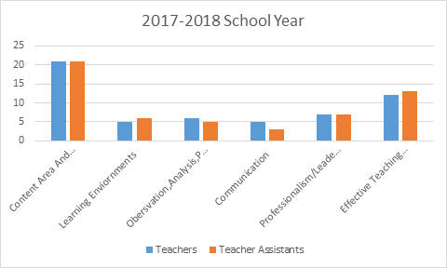

Mental Health
- 2 children were observed closely this school year to monitor behavior. No children were referred.

FCAC, Inc. Head Start Community Partners

Community Agency Service/s provided to Head Start

Fauquier County Public Schools | Provide space for 3 Head Start classrooms  Provide space for Head Start to use for program in-kind
Fauquier County Public Schools:  Special Education Department | Complete testing on children who are referred  Provide special education services to children with disabilities  Resource for teaching staff
Fauquier County Public Schools  School Nutrition Services | Provide Breakfast and Lunch to all Head Start children
Highland School | Invite Head Start children to theatrical performances/read to children  Donate books, hats and gloves to Head Start Children
Liberty High School | Provide space to use for any Head Start event
PRACEP- Piedmont Regional Adult Continuing Education Program | Provide GED (classes/testing) and ESL classes
Literacy Volunteers of Fauquier County | Provide basic literacy skills, computer skills, ESL classes
Fauquier County Health Department | Participate on Health Education Advisory Committee  Provide Immunizations/Physicals
Northern Piedmont Community Foundation- | Nicolaas and Patricia Kortlandt Grant to purchase the new edition of the Creative Curriculum.  Grant to purchase seat belt harnesses for buses.

Capital Group | Adopt a classroom at Christmas and provide baby doll/truck
Summit Bank | Adopt a classroom at Christmas and provide baby doll/truck
Dominion Energy | Adopt a classroom at Christmas and provide baby doll/truck, provided back packs with supplies to all 4 year olds, a shed for outdoor play
Our Savior Lutheran Church | Provide Food Baskets to families in need
Community Touch Inc. | Assist families in need with Clothing/Furniture Vouchers
Christ Church | Provide Easter Food Basket to families in need  Adopt a classroom at Christmas and provide baby doll/truck
F.I.S.H. (For Immediate Sympathetic Help) | Attend Teddy Bear Picnic  Provide Back Packs/School Supplies to families in need
Fauquier Community Food Bank/Thrift Store | Provide food/clothing to families in need and serve on policy council.
Town of Warrenton | Adopt a Family at Christmas, Strong Supporter of Head Start
The Wise Foundation | Donated $1,000 to the program
Warrenton Ruritan Club | Private Donation
Loeb Foundation | Strong Supporter of Head Start children and families
Leckner Auto | Provided Thanksgiving baskets to families

Fauquier Free Clinic- Dental  Fauquier Free Clinic | Contractual Agreement to provide Dental Screenings
Lord Fairfax Community College | Attended Health/Education/Parent Engagement Advisory Meeting  Work with Head Start parents to reach their educational goals  Work with Head Start to provide Early Childhood classes for teachers and staff
Enroll Virginia | Attended Health/Education/Parent Engagement Advisory Meeting
Fauquier County Public Library | Children visit the library on a monthly basis  Attend Parent Orientation, Transition Picnic, serve on Policy council.  Work in conjunction with RIF to provide books to children  Act as a resource for teachers and staff
American Health Services Inc. | Provide CPR/First Aid training to staff and parents  MAT training to staff
Health Connect America | Conduct monthly classroom observations  Serve as a resource to families and staff  Attend Health/Education Advisory Board Meeting  Assist with annual self-assessment
Fauquier Host Lions Club  Warrenton Sunrise Lions Club | Provide Hearing and Vision screenings to children  Volunteer during Christmas-play Santa Clause and bring gifts to children. Donated a car to transport parents to visit if necessary.
Colette Reynolds, MA CCC | Provide Speech and Language Screening on all Head Start children
Virginia Cooperative Extension (SCNEP) | Provide Training and nutritional information to parents  Water bottles for all children
Rappahannock-Rapidan Community Service Board’s (R.R.C.S.B.) | Help address the mental health, and special needs of Head Start students and their families through the Child Case Management Program
St. John's Catholic Church:  The Knights of Columbus  St. Vincent de Paul Society | Provide Food Baskets to families in need during Thanksgiving, Christmas and Easter  Adopt a classroom at Christmas and provide baby doll/truck. Provide emergency utilities assistance for families in need

KD & Herbert Stotler | Private Donation
St. Andrew’s Church | Adopted a family for Christmas
Virginia Palmer-Fuechsel | Knitted hats and gloves for the children
St. John’s Baptist Church Missionary | Adopted a family for Christmas
Moser Funeral Home | Assists the program with its needs for example; chairs
Eagle Pest Control | Adopted a classroom for Christmas
Robert Corum | Thanksgiving/Christmas Food Baskets
Vulcan Materials | Adopted a classroom for Christmas
Order of the Eastern Star View Point Chapter #117 | Donated money to the program for children’s needs at Christmas
View Tree Masonic Lodge #142 | Adopted Families at Christmas & Thanksgiving and are Reading Buddies
S.A.F.E (Services to Abused Families) | Provide Domestic Violence, Sexual Abuse, Child Abuse Awareness training for staff and families  Resource for Families and staff regarding abuse  Attend Family and Community Partnership Advisory Meeting
American Legion Post #360  Lt. Charles R. Anderson | Donated classroom supplies
St. James Episcopal Church | Purchased a Promethean Class Flow for Head Start; Reading Buddies for the children all through the year.

We would like to thank the many parents, grandparents, community partners and staff for their support of this program!

